Jaypee Institute of Information Technology, Noida
Department of Computer Science & Engineering and Information Technology



Major Project Title - Crime Rate Prediction Using Machine Learning

Enroll. No. Name of Student 21103292 Kul Chandra Bhatt 21103293 Anup Ghimire
21104060 Atul Khetan

Course Name: Major Project Part-2 Program: B.Tech. CSE
Semester: 8th

2024-2025

(I)

TABLE OF CONTENT
Chapter No. Topics Page No.
Chapter 1: Introduction 1-5
  - General Introduction 1
  - Problem Statement 1-2
  - Significance of the problem 2
  - Empirical Study 3
  - Brief Description of the Solution Approach 3-4
  - Comparison of existing approaches to the problem 4-5
Chapter 2: Literature Survey 6-15
  - Summary of papers studied 6-14
  - Integrated summary of the literature studied 14-15
Chapter 3: Requirement Analysis and Solution Approach 16-27
  - Overall description of the project 16-20
  - Requirement Analysis 20-23
  - Solution Approach 23-27
Chapter 4: Modelling & Implementation Details 28-36
  - Design Diagrams 28-31
  - Implementation details and Issues 32-33
  - Risk Analysis and Mitigation 33-36
Chapter 5: Testing 37-41
  - Testing Plan 37-38
  - Component Decomposition and type of testing required 38-39
  - List all test cases in prescribed format 39-40
  - Error and Exception Handling 40
  - Limitations of the solution 40-41
Chapter 6: Findings, Conclusions and Future Work 42-51
  - Findings 42-49
  - Conclusion 49-50
  - Future Work 50-51
References 52-54

(II)

DECLARATION

We hereby declare that this submission is our own work and that, to the best of my knowledge and belief, it contains no material previously published or written by another person nor material which has been accepted for the award of any other degree or diploma of the university or other university or other institute of higher learning, except where due acknowledgment has been made in the text.

Place: Noida, India Signature:

Date: Name:Kul chandra Bhatt,Anup Ghimire,Atul Khetan
Enrollment No. : 21103292, 21103293,21104060

(III)

CERTIFICATE

This is to certify that the work titled “Crime Rate Prediction Using Machine Learning” submitted by “Kul chandra Bhatt,Anup Ghimire and Atul Khetan” in partial fulfilment for the award of degree of B.Tech. of Jaypee Institute of Information Technology, Noida has been carried out under my supervision. This work has not been submitted partially or wholly to any other University or Institute for the award of this or any other degree or diploma.

Signature of Supervisor

Dr. Niyati Aggrawal

Assistant Professor (Senior Grade) Department of Computer Science and IT JIIT NOIDA, Sector – 62

(IV)

ACKNOWLEDGEMENT
We extend our sincere appreciation to everyone who contributed to the success of this major project.
We are deeply grateful to our Supervisor Dr. Niyati Aggrawal, whose guidance and support were instrumental in navigating the complexities of this project. Their expertise and insightful feedback significantly enhanced the quality of my work.
A special note of gratitude goes to our peers and friends for their collaborative efforts and the vibrant exchange of ideas. Their input played a crucial role in shaping the project and overcoming challenges.
We acknowledge our college Jaypee Institute of Information Technology, Noida for providing the necessary resources and a conducive environment for successful completion of the project.
This project has been a collective effort, and we are truly grateful for the support of each individual and entity mentioned. Thank you for being an integral part of this journey.

Signature of Student 1:
Name of Student : Kul Chandra Bhatt Enrollment Number : 21103292

Signature of Student 2:
Name of Student : Anup Ghimire Enrollment Number : 21103293

Signature of Student 3:
Name of Student 3: Atul Khetan Enrollment Number : 21104060

Date:

(V)

SUMMARY

The Crime Rate Prediction System operates as a machine learning-powered web application which provides forecasts for Indian metropolitan city crime development. The system based on historical NCRB data from 2014 to 2021 enables law enforcement agencies to view crime patterns trends ahead of time while optimizing resource usage. The system concentrates on estimating crime rates between cybercrime alongside murder, kidnapping and crimes targeting women and children together with eight additional types of offenses.
The system core consists of Random Forest Regression that analyzes encoded city and crime type information while automatically calculating population changes through yearly growth projections. Testing yielded a prediction success rate of 93.2% on the test evaluation set. Tests were conducted on Decision Tree, SVR and MLP Regressor as additional performance evaluation models.
The frontend operates from HTML CSS and JavaScript combined with Flask which provides the backend connectivity for this program. Through a partnership with Chatbase.co users can access a chatbot platform within their system that helps users find answers about how to use the application and emergency contact numbers and supported cities. The program offers two main functions which present predictions through categories alongside nationwide emergency contact numbers.
The system works to improve public safety while providing user-friendly data predictions for enhanced public security. The system serves as a major advancement toward more intelligent law enforcement and public safety awareness with potential future developments including real-time notification systems based on locations and multilingual interface capabilities.

(VI)

LIST OF FIGURES

S.No. | Figure | Page No.
1 | Sequence Diagram | 28
2 | Flowchart | 29
3 | Class Diagram | 30
4 | Architectural Diagram | 31
5 | Crime against various groups in different cities | 42-45
6 | Comparison between different algorithms | 45-46
7 | Main Page | 46
8 | About page | 47
9 | Working Model | 47
10 | AI Constable(Chat Bot) | 48
11 | ChatBot FAQ | 48

(VII)

LIST OF TABLES

S.No. | Table | Page No.
1 | Risk Analysis | 33-34
2 | Test Results | 37-38
3 | Component Decomposition and Type of Testing required | 38-39
4 | List of all test cases | 39-40
5 | Error and Exception Handling | 40

(VIII)

LIST OF ABBREVIATIONS

Abbreviation | Full Form
ML | Machine Learning
NCRB | National Crime Records Bureau
AI | Artificial Intelligence
UI | User Interface
NLP | Natural Language Processing
SVR | Support Vector Regressor
KNN | K-Nearest Neighbors
MLP | Multi-Layer Perceptron
LLM | Large Language Models
RF | Random Forest
DT | Decision Tree
Api | Application Programming Interface
CSV | Comma Separated Values
HTML | Hyper Text Markup Language
CSS | Cascading Style Sheets
JS | JavaScript
FAQ | Frequently Asked Questions
RMSE | Root Mean Square Error
R² Score | Coefficient of Determination
MAE | Mean Absolute Error
Chatbase | Chatbot Platform (used for integration)
Flask | Lightweight Web Framework for Python
pkl | Pickle File (Python serialized model)

Chapter 1: Introduction

General Introduction

Keeping citizens safe together with minimizing crime operations stands as a multifaceted obstacle within present-day urban environments. Urban growth of population and infrastructure increases the dangers of crime. Trusted crime forecasts remain out of reach for law enforcement agencies because they do not have sufficient predictive systems that work accurately. The standard police operation exists mainly in response mode through post-crime intervention. Strategic decision-making backed by data allows predictive policing to operate proactively as an anti-crime prevention strategy. The Crime Rate Prediction System operates from this vision by implementing machine learning algorithms to identify unrecognized patterns in historical crime records for making accurate forecasts regarding future crime trends.
The research examines the use of statistical learning algorithms on crime datasets for obtaining practical investigative findings. Apart from system development the project demonstrates how technological advancements empower governance while increasing citizen understanding of security issues. Users can provide three pieces of information to the system including a city choice and crime type and future time frame and receive computer-generated predictions about crime rate and case numbers. Such a change leads from existing crime mapping solutions to advanced crime prediction software that can identify patterns. The ultimate purpose focuses on giving administrative officials regulatory units and residents the ability to create safety decisions through genuine data patterns in place of hypothetical predictions.

Problem Statement

The crime trends in urban areas of India increase while law enforcement agencies must handle situations following crime occurrences instead of proactive prevention. The current approach depends intensely on past documentation and paper procedures for resource distribution across criminal activity zones. Modern fast-paced conditions demand better strategies than the approach being utilized in today's world. Currently there are no real-time prediction systems able to forecast crime patterns in cities from valid historical records. The lack of resource prediction technologies leads to erroneous deployment because critical areas may receive inadequate protection.

Detecting accurate crime predictions throughout different cities with distinct crime categories stands as an essential requirement. The broad dataset size and diverse city-level crime variations as well as shifting urban population characteristics create difficulties during problem-solving. Manual inspection of these extensive data sets requires both long processing time and leaves room for human errors. The system needs to generate information which police personnel alongside local authorities with limited technical knowledge can understand from the model outputs. The central issue of this project involves developing a user-friendly intelligent crime prediction system which functions as a dependable tool to forecast criminal activities through city, year and crime category entries.

Significance of the Problem

Such an achievement in building reliable crime prediction systems would have broad impacts on society. Such a system provides essential data support to law enforcement agencies for their decision-making processes. Crime appears as concentrated clusters in particular areas which demonstrate patterns that are relatively easy to predict. The identification of areas and times where crimes will likely happen permits police to create forward-thinking security methods through enhanced area surveillance and public education programs. Law enforcement agencies have the ability to cut down crime levels while making their jurisdictions safer for the public through their actions.
This system shows value for civic planners and government officials when used in their operations. Crime trends serve as a tool for urban planners to implement enhanced surveillance in particular zones also alongside improvements to necessary infrastructure and lighting elements. The design of public safety campaigns follows an approach where specific hazardous times and locations serve as organizing factors. Through this work the academic world gains knowledge about using data science and machine learning to resolve vital social problems. The system demonstrates promising growth prospects as it possesses the capability to enable mobile operation and database connectivity and can benefit from IoT device and CCTV streaming data in upcoming developments. When it comes to this problem resolution it is essential to prioritize responsible technology use because this leads to enhanced public safety measures.

Empirical Study

The research project utilizes data from actual crime records collected from the National Crime Records Bureau (NCRB) official website which maintains nationwide statistics in India. The research utilizes crimes reported over the period of 2014 through 2021 in 19 metropolitan Indian cities as its database. Ten major crime categories in the data comprise murder, kidnapping, crime against women, crime against children, cybercrime, economic offenses and others. The statistics were gathered manually through the combination of annual NCRB report figures. Every single entry in the dataset shows the crime case numbers which occurred in a selected city throughout a particular year.
The data needed machine learning compatibility so extensive preprocessing steps were executed. Standardization of city names together with encoding of crime categories and city regions and management of inconsistent and missing data points formed part of the preprocessing process. An estimation process based on projected population expansion rates was used to calculate future population projections which were incorporated into the dataset. Preprocessing of data involved conducting Exploratory Data Analysis (EDA) to uncover patterns and discover correlations as well as anomalies in the data records. The data revealed that cybercrime grew steadily throughout the years yet traditional crime patterns demonstrated unpredictable fluctuations. Building our machine learning models required the fundamental information which came from empirical analysis of the data. Knowledge of Indian crime data characteristics emerged through this process which enabled us to develop suitable procedures.
  - Brief Description of Solution Approach

We commence our method for solving crime prediction by converting data into a processing-friendly form for computers. The program assigns numerical values to crime categories and cities while the population data receives scaling treatment based on projected population increases. The prediction system core contains a Random Forest Regression model built as an ensemble method because of its outstanding performance with noisy data and imbalanced datasets. The system receives encoded values of year, city, crime category with projected population figures then produces the predicted crime rate measurement per 100,000 people as its output.

The classified output results from the model create four recognizable crime risk zones starting from Very Low Crime Area moving towards High Crime Area and ending with Very High Crime Area. The calculation for predicted case numbers occurs through multiplication between the crime rate and population numbers from the chosen year. The model demonstrated 93.2% prediction accuracy while processing actual crime data through its validation process.
A user-friendly interface powers the Flask web application deployment of the model. Users proceeding through the system must first choose their city along with the crime category and then specify the year before receiving predictions. The Chatbase.co chatbot integration enables users to find answers about the prediction model along with supported cities and crimes and emergency contact numbers. The solution provides practical predictive capabilities to users who have diverse technical abilities through its powerful artificial intelligence combination with intuitive user interfaces.

Comparison of Existing Approaches to The Problem

Most existing crime analysis systems depend on fixed crime mapping tools that show previous crime distribution through dashboards or heatmaps. These systems excel at presenting patterns but they cannot produce predictive alerts or future forecasts. Law enforcement tools and municipal tools mostly operate in a reactive manner because they track crimes only after they occur without providing forecasts about upcoming crime locations. Programs with these characteristics make citizens enter data manually and do not operate effectively with large datasets that span multiple urban areas.
In contrast, our approach leverages machine learning for actual forecasting. Through historical data training we obtain capabilities to track temporal patterns and interpret seasonal crime patterns while integrating demographic changes in urban areas. Through implementation of Random Forest techniques the algorithm successfully maintains a capacity to process nonlinear patterns among data while preventing overfitting. The system performs three important security functions which begin with threat detection then proceed to calculate forecasted case numbers and generate relevant emergency contact data based on the crime type. Users can access the system most easily because an interactive chatbot enhances its functionality.

Conclusion

The shift toward forecasting crime with artificial intelligence replaces passive reporting systems to build advanced public safety infrastructure that serves as the cornerstone of modern governance.

Chapter 2: Literature Survey
  - Summary of Papers Studied

Author | Summary | Limitation | Prediction
Muhammad Alkaff,  Nurul Fatanah Mustamin, Gusti Aditya Aromatica Firdaus. “Prediction of Crime Rate in Banjarmasin City Using RNN-GRU  Model”(2022) | The research creates a model for Banjarmasin City Indonesia crime rate prediction which uses Recurrent Neural Network (RNN) with Gated Recurrent Unit (GRU) architecture and incorporates inflation rate and discretionary income variables. The model integrates information about the inflation rate and discretionary income data in its analysis. The  GRU-RNN model demonstrated 0.84 R-Squared value together with 2.21 RMSE value. GRU stands as a simplified version of the RNN algorithm which outperforms the LSTM Neural Network for adapting between diverse time frames and Vanishing Gradient issues. The model includes both Update gate (zt) and Reset gate (rt) components while needing fewer inputs compared to | The forecasted value shows an insufficient closeness to the initial amount in comparison. A low number of data points hinders the process of model training in this particular dataset. | The forecasted value shows an insufficient closeness to the initial amount in comparison. A low number of data points hinders the process of model training in this particular dataset.

 | LSTM so it can generate maximum results from reduced data volumes.
Qifen Dong, | The research examines crime | The full variant of the proposed | Tests of the proposed
Ruihui Ye, | amount forecasting through | model 2DCONV-LSTM-f failed | 2DCONV-LSTM
Guojun Li. | analysis of spatial and temporal | to achieve optimal results | model utilized various
“Crime amount | linkages and the integration of | because additional auxiliary | levels of auxiliary data.
prediction based | various crime-connected | data decreased prediction model | The research showed
on 2D | supplementary information. | effectiveness. Research has | data addition elevated
convolution and | The paper makes four primary | validated that excessive | predictive power so the
long short-term | contributions including | auxiliary data includes too | 2DCONV-LSTM-d
memory neural | temporal autocorrelation and | much repetitive information | variant achieved
network”(2022) | spatial correlation analysis of | that causes adverse effects on | optimal performance
 | crime data as well as exploring | the proposed prediction model | with a RMSE value of
 | relationships between crime | performance. | 9.981. The proposed
 | data and auxiliary sources and |  | 2DCONV-LSTM
 | designing a crime amount |  | model demonstrated
 | prediction model using 2D |  | superior performance in
 | convolution and long |  | areas with
 | short-term memory neural |  | medium-high crime
 | networks (2DCONV-LSTM) |  | levels except when the
 | followed by experiments with |  | crime rates declined.
 | real-world datasets to measure |  | When applied to areas
 | prediction accuracy. Results |  | with medium and
 | indicate that the proposed |  | medium-low crime
 | 2DCONV-LSTM system |  | rates the best
 | achieves superior prediction |  | 2DCONV-LSTM
 | results against SVR and LSTM |  | variant diminished
 | while displaying adjustable |  | aRMSE values by 0.5%
 | accuracy according to the crime |  | and 0.3% over

 | rate of evaluation regions. |  | Just-LSTM.
Wajiha Safat, | Tests of the proposed | The short 5-year dataset size | The evaluation of
Sohail Asghar, | 2DCONV-LSTM model | makes it difficult to produce | predictive accuracy
Saira Andleeb | utilized various levels of | accurate future forecasting. The | found that XGBoost
Gillani. | auxiliary data. The research | performance of crime | achieved the highest
“Empirical | showed data addition elevated | prediction systems would have | accuracy rates of 94%
Analysis for | predictive power so the | been improved by using hybrid | for Chicago and 88%
Crime Prediction | 2DCONV-LSTM-d variant | models together with methods | for Los Angeles. The
and Forecasting | achieved optimal performance | that enhance their accuracy. | performance metrics
Using Machine | with a RMSE value of 9.981. |  | RMSE and MAE
Learning and | The proposed 2DCONV-LSTM |  | evaluated the
Deep Learning | model demonstrated superior |  | scale-dependent error
Techniques” | performance in areas with |  | from an LSTM model
(2021) | medium-high crime levels |  | implementation. The
 | except when the crime rates |  | results of exploratory
 | declined. When applied to areas |  | data analysis revealed
 | with medium and medium-low |  | 35 different crime types
 | crime rates the best |  | in Chicago as well as
 | 2DCONV-LSTM variant |  | 39 crime types in Los
 | diminished aRMSE values by |  | Angeles that displayed
 | 0.5% and 0.3% over |  | reduced criminal
 | Just-LSTM. |  | activity in Chicago but

increasing criminal activity in Los Angeles over recent years.
Forecasting through an ARIMA analysis indicated that Chicago's crime density is expected to maintain moderate growth until it becomes stable while Los Angeles will have a sudden reduction in crime rates.
Sakib Mahmud, Musfika Nuha, Abdus Sattar. “Crime Rate Prediction Using Machine Learning and Data Mining”(2021) | The research examined the connection between various criminology-related features and crime activity in existing literature. The author deployed Z-Crime Tools along with Advanced ID3 algorithms as part of data mining technology while employing K-Means Clustering and deep learning algorithms with random forest and naïve Bayes algorithms and multi-linear regression.  Through the Apriori algorithm and Naive Bayes algorithm the author conducted criminal trend | The usage of data for crime rate predictions started in the last three years because of low crime occurrences across various areas. | The study demonstrates that K-nearest neighbor achieves the highest level of precision as a crime rate prediction tool. The accuracy levels for Linear, Naive Bayes and KNN algorithms amounted to 73.6%, 69.5% and  76.9% respectively.

 | detection while providing crime rate predictions. Naive Bayes joined a set of classification algorithms to assign data objects in a dataset into defined classification groups.
Gaurav Hajela, | Crime manifests as | A wiser method should have | Crime prediction
Dr. Meenu | spatial-temporal patterns | been used for dividing the data | models finish their
Chawla, Dr. | throughout geographical | between training, validation and | operation by
Akhtar Rasool. | regions according to research | test groups. | conducting state of art
“A Clustering | studies. Crime detection |  | technique-based
Based Hotspot | requires various recognition |  | predictions. The
Identification | methods including urban or |  | prediction model uses
Approach For | census-based indicators |  | four classification
Crime | combined with street light and |  | techniques which
Prediction” | daylight metrics as well as |  | include Naive Bayes
(2020) | social media-based indicators |  | (NB), Naive Bayes with
 | and population flow indicators |  | kernel estimator (NB
 | and climate-based indicators. A |  | -k), Decision Tree
 | hotspot describes any specific |  | (REPTree) and
 | area which contains greater |  | ensemble approaches.
 | incidences of criminal activity |  | Hotspot analysis leads
 | in comparison to its |  | to better accuracy
 | surrounding regions. The paper |  | according to the results
 | develops a prediction model for |  | obtained from both
 | San Francisco crimes that |  | conditions. The cluster
 | implements hotspot detection |  | number takes the place
 | then prepares crime data before |  | of X and Y in KMeans

 | using a prediction method. This |  | clustering when
 | study describes its performance |  | identifying hotspots.
 | assessment criteria and shows |  | The best results emerge
 | obtained result data. |  | from k=4 when it
 |  |  | operates with hotspot
 |  |  | detection while
 |  |  | Decision tree
 |  |  | classification reached
 |  |  | an accuracy of 83.95 %
 |  |  | which surpasses that of
 |  |  | Naive Bayes.
Masoomali | This paper examines the | Muslim encourages predictions | The analysis performed
Fatehkia, Dan | potential effectiveness of | for assaults, burglaries and | three separate
O’Brien, Ingmar | Facebook Advertising API data | robberies because it relies on | regression models
Weber. | in understanding how | limited available data. | which assessed crime
“Using | individual-level procedures |  | rate predictions for
Facebook | affect neighborhood crime |  | assaults and burglaries
interests to | rates. The study first explores |  | and robberies. The
improve | established criminogenesis |  | research checked
predictions of | theories that involve elements |  | different scenarios that
crime rates in | such as poverty as well as |  | included demographic
urban | social disorganization and |  | data exclusively as well
areas”(2019) | income disparities and |  | as specific Facebook
 | impulsive behavior. The |  | activity data while
 | proposed methodology explains |  | taking into account
 | how the API enables the |  | neighborhood age
 | measurement of interests within |  | distributions and
 | Facebook user populations |  | citywide crime baseline
 | from specific ZIP codes |  | numbers. Research data

 | allowing researchers to reveal |  | indicated that joint

 | population behavioral and |  | analysis of
 | attitudinal traits. The study |  | demographic factors
 | nature is clearly stated as |  | and Facebook interests
 | exploratory which means |  | provided maximum
 | readers should understand the |  | predictive accuracy for
 | results show predicted trends |  | all three offense types
 | for reported crimes as distinct |  | through adjusted R2 for
 | from actual crime occurrences. |  | in-sample analysis and
 |  |  | MAE for out-of-sample
 |  |  | predictions.
Charlie Catlett, | The paper outlines a method to | The clusters appeared with | The research evaluated
Eugenio Cesario, | identify dangerous crime areas | extremely big dimensions after | various methods for
Domenico Talia, | throughout urban territories | splitting. The study encountered | extracting crime
Andrea Vinci. | along with their corresponding | difficulties in identifying the | predictors between
“Spatio-temporal | crime prediction capabilities. | proper correlation between | ARIMA models and
crime | The algorithm performs | crime trend patterns and various | three traditional
predictions in | multiple operations including | city events. | regression algorithms
smart cities: A | spatial analysis for crime dense |  | (RandomForest,
data-driven | region detection and |  | REPTree, ZeroR).
approach and | model-based investigation of |  | Among the prediction
experiments”(20 | individual regions. The study |  | approaches ARIMA
19) | applies experimental results to |  | ranked highest in
 | analyze the Chicago and New |  | accuracy for one-year
 | York City urban areas. Spatial |  | forecasts within regions
 | analysis along with temporal |  | with highest crime
 | crime forecasting achieved high |  | density in both Chicago
 | levels of accuracy based on the |  | and New York City.

 | experimental findings. Other |  | Building evidence
 | regression analysis approaches |  | shows that the

 | proposed in literature undergo a |  | autoregressive model
 | comparison of results while the |  | suits accurately
 | paper outlines a method for |  | predicting crime
 | forecasting urban crime |  | statistics.
 | patterns through spatial analysis
 | combined with auto-regressive
 | models. The system operates
 | through assessment of regions
 | with elevated crime potential
 | together with crime zones with
 | minimal crime activity while
 | taking seasonal rate fluctuations
 | under consideration.
Ms. Vrushali | The system transforms crime | The prediction results would be | The system introduces
Pednekar, Ms. | data into format suitable for | more accurate when focusing | an innovative
Trupti Mahale, | data mining operations as an | on a single state or regional | framework to cluster
Ms. Pratiksha | approach to assist detectives in | area. The system lacks | and predict crimes
Gadhave, Prof. | quicker crime-solving. The | capability to forecast when | through genuine crime
Arti Gore. | system involves several steps | crimes take place at specified | data. The proposed
“Crime Rate | including crime analysis | times | system predicts Indian
Prediction using | followed by target dataset |  | crime-prone areas for
KNN”(2018) | extraction and then data |  | specific days despite
 | pre-processing and data mining |  | the unidentified
 | activities before interpretation |  | parameters affecting the
 | of discovered knowledge uses. |  | data mining
 | A general algorithm within the |  | preprocessing outcomes

 | proposed model accepts crime |  | and training-test dataset
 | database data from government |  | quality and feature
 | repositories and transforms this |  | values.

information into an output correlated dimensions model for analysis and prediction. The system uses different data mining approaches to forecast how often crime occurs through analysis of current spatial enforcement data. The data treatment process along with missing value management ensures that mined data maintains high quality. The system allows users to generate SQL or report output for pattern interpretation and action-based decision making through the acquired knowledge.

  - Integrated Summary of the Literature Studied
Research evidence shows there is a growing interest in implementing machine learning (ML) together with deep learning (DL) while using data mining approaches for crime rate prediction across different urban zones. Experts examine multiple sources of data while developing model architectures which use evaluation metrics to enhance both accuracy and usability in crime prediction systems.
The proposed GRU-based RNN model from Alkaff et al. processed time-series crime data

with R² = 0.84 accuracy level. The model faced difficulty due to insufficient training data although it remained easy to implement and usable with small datasets. The research of Dong et al. presented a 2D convolutional LSTM (2D CONV-LSTM) technique which combines spatial patterns from auxiliary datasets and temporal information. The model performed
better than standard LSTM and SVR models only in high-crime areas but its accuracy suffered when more than necessary auxiliary variables led to increased noise in predictions.
Wajiha Safat et al. analyzed U.S. crime data through comparative research that applied several ML algorithms. XGBoost achieved the best model performance among all strategies despite the research relying on five years of limited crime data. The research group demonstrated the utility of combining models by employing KNN and ID3 and Z-Crime tools although their performance was limited by insufficient crime data availability.
Through his work Gaurav Hajela implemented hotspot detection through clustering steps that led to improved model classification performance. The exceptional work by Fatehkia et al. demonstrated Facebook interest data integration into predictive models that shows behavioral information strengthens demographic data in crime prediction systems. Through their research Charlie Catlett et al. demonstrated ARIMA and regression models succeed in predicting spatial seasonal city crime patterns with high accuracy for one year ahead.
Pednekar et al. built a simplified clustering and classification-system for Indian crime data by implementing KNN techniques that included pre-processing methods and feature selection routines and missing data treatment protocols.
In summary, the literature showcases a transition from traditional statistical methods to intelligent, hybrid, and multi-modal models. Most research proves that the quality of data alongside pre-processing techniques and feature selection choices matter the most. The majority of regional predictions from different models prove accurate but the process faces three major obstacles in real-time implementation and universal geographic applicability. The current project evaluation supports its objective to combine Random Forest ensemble ML methods with intuitive UI and chatbot features in order to connect academic research with practical applications.

Chapter 3: Requirement Analysis and Solution Approach
  - Overall Description of the Project

The Crime Rate Prediction System serves as a data-driven web application which makes use of machine learning algorithms to forecast crime rates throughout Indian metropolitan cities. Users can access this system by picking the desired city along with the year and crime type which generates expected crime rate and case predictions. This system functions by using past NCRB data from 2014 to 2021 to generate supportive information for police departments and public safety needs. The Random Forest Regressor serves as the prediction model after examining several algorithms because of its favorable performance balance between accuracy and stability.
The application uses Flask as its Python web framework together with an HTML CSS and JavaScript front-end interface. A chatbot with Chatbase capabilities provides the platform with two functions: it helps users ask questions and it guides them through platform use. A section with emergency contact data exists within the system to guarantee user protection and awareness.
Module-Wise Breakdown

- Crime Data Preprocessing Module

The module applies cleaning and encoding operations while applying data scaling to NCRB raw data for machine learning purposes.
Key Functions:

  - From 2014 to 2021 the model cleans and normalizes information obtained from 19 metro cities.
  - The program uses label mapping to convert crime categories along with metro cities into encoded data.
  - The module deals with data errors as well as irregular data formatting while handling missing values.
  - The system includes calculations to predict population growth during upcoming years.

Assumptions & Constraints:

  - The accuracy of the analysis depends on how well the historical data was obtained.
  - The population growth rate estimates exist only as approximations because they reflect data from the past that might be outdated.

- Machine Learning Model Training & Evaluation Module

The training process of multiple ML models against historical data enables selection of the algorithm which produces the most precise crime prediction results.
Key Functions:

Implements the following models:

  - Random Forest Regressor: Best performance (R² = 0.932). Handles large data well and resists overfitting.
  - MLP Regressor (Neural Network): Due to its performance it requires more training time and depends heavily on parameter adjustments.
  - K-Nearest Neighbors (KNN): Simple, intuitive, but less effective with noisy data.
  - Decision Tree Regressor: Easy to interpret, moderate accuracy.
  - Support Vector Regressor (SVR): Lower accuracy, slower on large datasets.
  - Splits data into training and test sets.
  - Evaluates each model using MAE, MSE, and R² score.
  - Selects Random Forest as the final deployed model.

Assumptions & Constraints:

  - Evaluation limited to 2014–2021 data.
  - The existence of smaller crime data sets for specific city categories and categories of crime reduces the reliability of the predicted model.

- Crime Rate Prediction Logic Module

The central section of the system transforms the encoded user input data for model-based crime rate prediction.

Key Functions:

  - The program obtains city, year, and crime type values through UI.
  - The system receives inputs for population forecasts which it both transforms and retrieves from its storage system.
  - Passes inputs to trained ML models for prediction.
  - The system calculates predicted crime cases while determining risk levels through Low and High categories.
Assumptions & Constraints:

  - The model restricts its responses to the pre-established set of 10 crime categories.
  - The model has no capability to handle unexpected social or political events.

- Web Application Interface Module

Users can easily access the model through a simple and efficient interface hosted on a browser platform.
Key Functions:

  - The web application utilizes Flask as its backend routing mechanism.
  - The program uses HTML/CSS/JS to generate the graphical user interface which shows information to users.
  - The application implements responsive design that enables optimal display on various desktop and mobile devices.
Assumptions & Constraints:

  - Basic UI layout; no data visualizations yet.
  - Browser compatibility may vary slightly.

- Chatbot Integration Module

The Chatbase application delivers an assistant which guides users by responding to their commonly asked questions throughout the UI.
Key Functions:

  - A Chatbase bot achieves functionality after receiving training through 7–8 pairs of appropriate questions and answers.
  - The assistant responds to inquiries regarding supported areas and model information as well as crime classification.
  - Accessible from any screen as a floating chat icon.

Assumptions & Constraints:

  - Purely pre-established questions are all it can handle along with its inability to conduct data-driven language processing.
  - Internet required for real-time responses.

- Emergency Information Display Module

Static section on the UI displaying national emergency helplines.

Key Functions:

  - The application offers access to police, ambulance, cybercrime, and women emergency contact numbers.
  - The feature makes the application more practical for actual safety situations.

Assumptions & Constraints:

  - The application displays data which is static because it does not originate from current government systems.
  - Users need to make direct emergency service contacts by themselves.

- Testing, Debugging, and Validation Module

System reliability is achieved through various testing phases that confirm its operational accuracy.
Key Functions:

  - A testing method uses established and boundary scenarios as inputs for model testing.
  - Manual validation of output predictions.

  - The team performed debugging activities on the Flask backend along with the chatbot functions and the user interface elements.
  - The implementation contains fundamental exception management systems together with form verification procedures.
Assumptions & Constraints:

  - The project depends on manual testing methods instead of implementing automated testing frameworks.
  - Limited user base for external validation.

  - Requirement Analysis

The Crime Rate Prediction System achieves usability combined with scalability and accuracy by careful assessment of functional and non-functional requirements for crime forecasting with risk-level classification and chatbot assistance and public safety features. The project embraces machine learning to generate reliable crime predictions and makes the system available as well as informative to both public users and law enforcement personnel.

    - Functional Requirements

- Crime Rate Prediction Module

City, Crime Type, and Year Input Interface:

Users should access a dropdown interface to choose a city and a crime type and to input a prediction year.
Crime Prediction Engine:

After users provide system data the values need encoding followed by processing through trained machine learning models such as Random Forest and SVR, Decision Tree Regressor along with K-Nearest Neighbors and MLP Regressor. A predicted crime rate is produced by applying the best-performing model which is Random Forest.
Crime Output Display:

The system should first calculate predicted crime numbers after which it must display classified crime intensities utilizing Very Low, Low, High and Very High categories.
- Emergency Information Module

Contact Directory Display:

A visible section of the application must showcase Police and two emergency numbers that include Cyber Crime and Ambulance and Women Helpline.
Integration with Chatbot:

Users must be able to receive emergency contact information by asking directly for the women helpline number or the cybercrime contact through the chatbot interface.
- Chatbot Integration Module

Predefined Question Handling:

The chatbot needs to answer at least seven through eight predefined questions which cover information about the app features with all available cities present along with the prediction model use.
Chat Support Integration:

All user pages must display this function and it must provide instant responses through the Chatbase API connection.
- Admin/Backend Module (Model + Data)

Model Selection and Accuracy Validation:

Multiple model testing should be possible through the backend system by using R² MAE and RMSE metrics for evaluation and verification. The chosen model needs to preserve its accuracy performance at 90 percent and above.
Input Encoding and Population Scaling:

The database referencing files should establish corresponding values for both city designations and crime classifications during encoding. The model needs year-based population scaling as a method to enhance prediction accuracy.

    - Non-Functional Requirements

- Performance

- Following user input submission the system needs to generate crime rate predictions that take no longer than 2 seconds to appear.
- Predefined queries from the chatbot need to deliver their response within a maximum 1–2 second wait time.
- Usability

- The system needs an intuitive user interface that enables simple navigation between both desktop and mobile interfaces.
- All prediction outputs need to have clear labeling alongside visual indicators which can be distinguished through badges or labels.
- Security and Privacy

- All user data remains undisclosed to the system because no data is stored or tracked and basic data privacy requirements are met.
- The system should feature full data encryption and access controls whenever it connects to real user accounts in the future.
- Maintainability

- The application needs to have modular design because Flask routes must be separate from both chatbot logic and ML model code which must be easily updatable.
- The update procedure for Chatbot FAQs and model files operates separately from each other.
- Portability

- Users should be able to access the system through all contemporary browsers while the software works with Windows macOS and Linux operational systems.

- For optimal client-side performance the application must operate without depending on any server system in the local area.
- Scalability

- The system architecture needs to enable seamless integration of future additional cities beyond London as well as new crime types and connection to live data Application Programming Interfaces (APIs).
- The system needs to enable effortless additions of optional features such as real-time mapping and language translation and mobile applications without requiring extensive redesign.
  - Solution Approach

To create an effective smart crime prediction system for accurate forecasting across user groups including the public along with police forces and administrative staff it is essential to develop a strong base utilizing modular architecture which shows scalability. The system integrates web-based automation with Machine Learning (ML) and static mapping data that receives chatbot help in its operations. The system intended to assess upcoming crime rates in Indian metropolitan cities by processing data from past events alongside projected population numbers and crime pattern trends. The following section explains module designs together with algorithm implementations while describing their interconnected operations to produce precise predictions along with user-friendly interfaces.
- Overview of the Solution

The Crime Rate Prediction System functions as a Flask application through which users access multiple machine learning models and static data mapping files and a prediction engine and a chatbot interface for help. The system consists of three fundamental modules that work together for its operation.
  - Crime Rate Prediction Engine
  - Emergency Info and Risk Categorization
  - Chatbot Assistant for System Help and FAQ

The solution includes distinct modules which collaborate to create an integrated system for interactive user navigation. The implemented architecture maintains understandable design elements that promote both easy expansion capabilities and visible model processes.
- Module-wise Breakdown

- Crime Rate Prediction Engine

Objective: The system aims to generate crime rate along with forecasted case numbers by processing user-selected city data and year data and crime type selection.
Input:

  - The application accepts City choice and Crime Type condition and Year from users.

Preprocessing:

  - According to the system design plan the selected inputs need static encoding through City_Mapping.txt and Type_Mapping.txt files.
  - The program calculates predicted population numbers by making projections from historical growth rates for the chosen year.
Model Selection:

The development process included implementing various ML models for testing until selecting one model for final use:
  - Random Forest Regressor proved to be the best forecasting method with R² accuracy reaching 0.932 and solid performance with respect to variance.
  - The MLP Regressor demonstrates effective performance although it demands additional parameter adjustments.
  - K-Nearest Neighbors (KNN): Simple and interpretable, lower performance.
  - Decision Tree Regressor shows quick performance with its lightweight structure yet it tends to develop excessive fits in the data.
  - The Support Vector Regressor (SVR) provides stability but delivers minimal effectiveness with extensive or row data.

Prediction Logic:

  - The model receives encoded input that has been transferred from the selected model.
  - The model generates predictions for the crime rate that amounts to people per 100,000.
  - Final result is calculated as: Expected Cases = (Crime Rate × Projected Population) / 100,000
  - The prediction results include numerical data and risk categories which span from Very Low to Very High.
- Emergency Info and Risk Categorization Module

Objective: Provide contextual crime category levels and show emergency contact numbers for user safety.
Key Features:

  - The visual categories display the expected crime rates which the model has predicted.
  - Very Low, Low, High, Very High.
  - Displays India’s essential helpline numbers:
  - The interface presents Emergency contact connections that include Police and Women Helpline and Cybercrime and Ambulance services.
Display Logic:

  - Static section in the UI for visibility.
  - Also retrievable via chatbot queries like “show emergency contacts.”

- Chatbot Assistant Module

Objective :The application directs users through its functions as well as provides answers to frequent system queries.
Input:

  - The user submits inquiries by utilizing normal English-speaking language.

Technology Used:

  - Chatbase: This platform allows outsourcing of chatbot development to train it with seven to eight fundamental FAQs.
  - The chatbot system provides pre-programmed answers which match specific user inquiries.
  - Users ask this question to understand why the app exists.
  - “Which cities are supported?”
  - “How accurate is the prediction?”

Capabilities:

  - Explains how the app works
  - There are multiple methods through which users access explanations regarding output interpretation.
  - Shares emergency contacts when asked
  - No supplemental NLP framework exists along with no connection to external LLM because the system handles app-based FAQ queries solely.
- Integration & Flow

  - The development team created the system with modular structure which provides:
  - The frontend portion allows users to enter information while it displays output and emergency information and integrates the chatbot interface.
  - The backend function receives input, runs the model calculations on that input then it generates the prediction output.
  - The chatbot provides answers which address questions focused on the application.

Each module is independent:

  - The system enables simple bug correction and new model implementation.
  - The system structure allows future features such as heatmaps and geo-location and real-time crime feeds to be scalable.
- Error Handling & Feedback

  - The system requires three primary steps for becoming both easy to use and reliable.
  - The system requires users to validate dropdown contents prior to generating predictions.

  - The system provides simple "empty input" and "invalid year" feedback that users can easily understand.
  - The backend system contains error processing capabilities which handle prediction model issues as well as encoding problems.
- Future Scope

  - The system features scalable components as well as future upgrade possibilities. Possible enhancements include:
  - Integration of real-time crime data via APIs.
  - Voice-enabled chatbot for improved accessibility.
  - Multilingual support (Hindi, Bengali, etc.).
  - The system can display crime heatmaps using Leaflet or Mapbox technology based on geographical locations.
  - An interface tool enables administrative users to load fresh city and crime information automatically.

Chapter 4: Modelling and Implementation details
  - Design Diagrams:
    - Sequence Diagram:
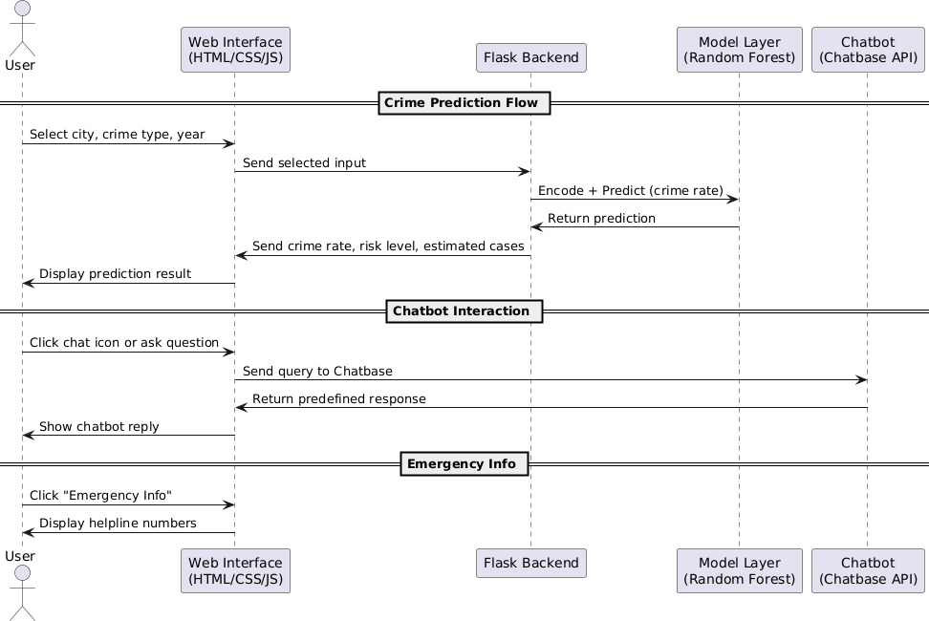

Fig 1. Sequence diagram

    - Flowchart
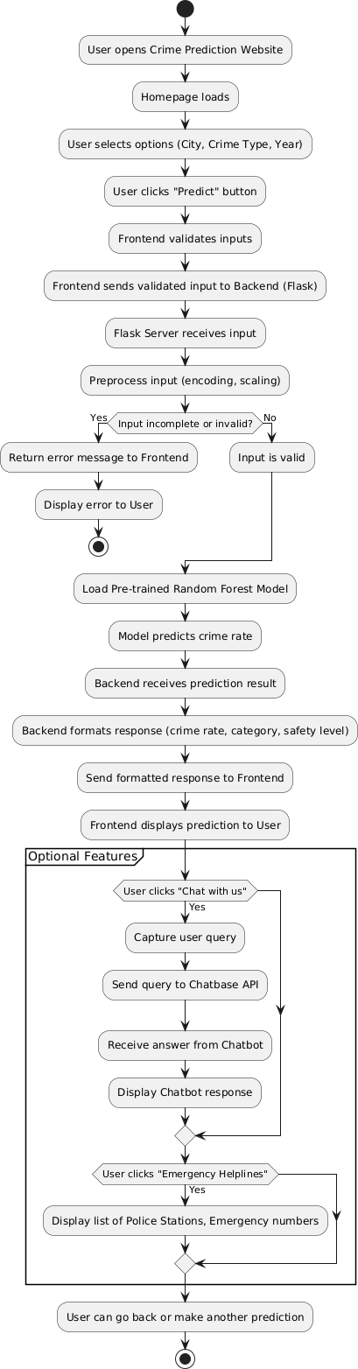

Fig 2. Flowchart

    - Class Diagram

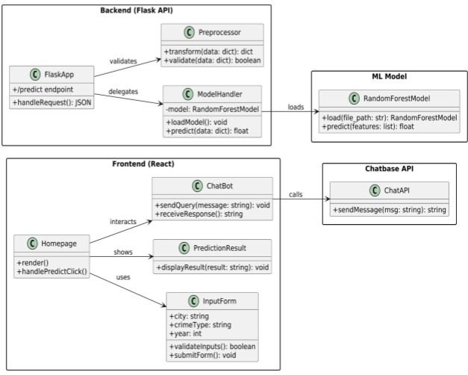

Fig 3.Class diagram

    - Architectural Diagram
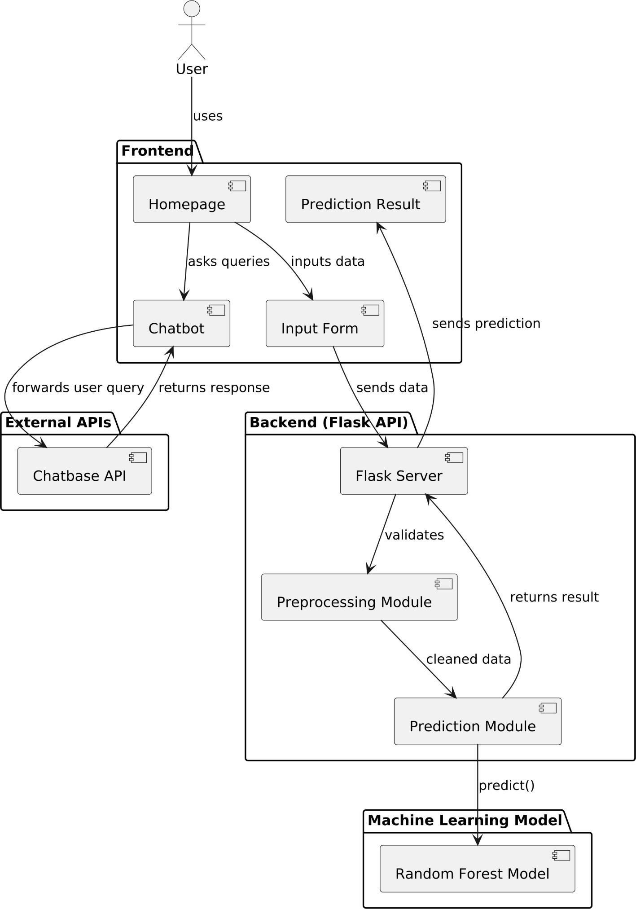

Fig 4. Architectural diagram

  - Implementation details and issues

The Crime Rate Prediction System exists as a solution that uses Flask for back-end operations alongside standard HTML/CSS/JavaScript tools for the front-end interface. This application divides its functionality into different sections starting from model prediction and continuing through chatbot integration and view generation through to input screening. The models including Random Forest and MLP Regressor along with Decision Tree and KNN and SVR received training through category-wise and city-wise historical crime data from NCRB. The implementation of the chatbot used Chatbase platform for training that incorporated specific FAQs regarding system functionality.
Implementation Details:

- Crime Prediction Module:

Five machine learning models including Random Forest Regressor, MLP Regressor, SVR, Decision Tree and KNN underwent training and evaluation testing. Flask deployed the best model called Random Forest using a saved .pkl file.
- Frontend Interface:

The application displays HTML/CSS design that incorporates three dropdown selection fields for city and year and crime categories. The system shows results dynamically through an output design interface.
- Chatbot Integration:

A floating Chatbase chatbot widget integration provided users with training for answering at least 7–8 system-related queries involving cities and model performance as well as contact information.
- Emergency Contacts Module:

Displays a static list of helpline numbers for police, cybercrime, women’s helpline, etc.
Challenges Faced:

Data Encoding & Preprocessing:

The structured data from NCRB required manual changes by multiple operators which were then mapped through .txt files.
Model Compatibility Issues:

The system displayed unsuccessful prediction results because its initial test encoding failed to match correctly.
Chatbot Limitations:

The Chatbase bot functioned with predefined questions although dynamic NLP capabilities surpassed the current development parameters.
UI Responsiveness:

The user interface of Ecss required manual intervention by the web developer to provide optimal viewing performance on mobile screens.
Hosting Constraints:

The local platform worked successfully but the system needed compression models with routing optimizations to become ready for cloud deployment.
The project implemented core functions effectively at the same time creating environments that were easy to use while maintaining system stability despite facing some issues.

  - Risk Analysis and Mitigation

Risk ID | Classification (SEI Taxonomy) | Description of Risk | Risk Area | Probabili t y (P) | Impac t (I) | RE (P ×I)
R1 | Requirements Stability | Changing UI layout or input logic late | Requirements & Inputs | H | H | 25

 |  | in development
R2 | External Dependencies | Unavailability of Chatbase or mapping files | External Inputs | M | H | 15
R3 | Budget Constraints | Server deployment limitations due to resource costs | Budget | M | M | 9
R4 | Testing Environment | Lack of automated testing frameworks | Testing Environment | L | H | 5
R5 | UI/UX Stability | Web UI may break under high-load or unvalidated inputs | UI/UX Stability | H | M | 15
R6 | Model Performance | Slower inference or lower accuracy for certain cities/crime categories | Model Performance | M | H | 15
R7 | Security | Exposure of model routes or emergency numbers to frontend tampering | Data Security & Privacy | M | H | 15
R8 | Monitoring | Inability to track or log user errors and feedback | System Monitoring | M | L | 3

Risk Area Wise Total Weighting Factor:

S No. | Risk Area | # of Risk  Statements | Weights (In + Out) | Total Weight | Priority
1 | System Monitoring | 1 | 11+1 | 12 | 1
2 | UI/UX Stability | 1 | 4+4 | 8 | 2
3 | Requirements & Inputs | 1 | 1+6 | 7 | 3
4 | Model Performance | 1 | 4+3 | 7 | 4
5 | Testing Environment | 1 | 2+3 | 5 | 5
6 | External Inputs | 1 | 0+2 | 2 | 6
7 | Budget | 1 | 0+2 | 2 | 7
8 | Data Security & Privacy | 1 | 0+1 | 1 | 8

Mitigation Approaches:

- R1 – Changing Requirements:

The team checked their alignment during regular weekly meetings. All requirement modifications were documented before receiving new prioritization.
The system proved highly effective at stopping both scope expansions and design problems.
- R2 – External Dependencies:

Local storage became the solution for backup model files along with backup datasets. An offline FAQ system was considered as an alternative backup strategy for the chatbot system.
Effectiveness: Mitigated disruption risk successfully.

- R3 – Budget Constraints:

The server did minimal processing while the team used local execution for demonstration purposes. Avoided unnecessary cloud dependencies.

The proposed solution combines price effectiveness with appropriate features to match budget requirements.
- R4 – Inadequate Testing:

The testing process included manual execution for various input conditions supported by error documentation within the Flask framework.
The system successfully identified errors in advance although it lacked automated functions.
- R5 – UI Crashes:

Front-end and validation improvements solved the UI presentation issues. Effectiveness: Resulted in a smoother experience on desktop and mobile.
- R6 – Model Performance:

The final model choice was Random Forest since tests performed on five candidates led to the discovery of documented performance boundaries.
Effectiveness: Provided a balanced model with stable output.

- R7 – Security:

The system operates without collecting user data and it destructively processes all entry inputs in memory fluctuations.
The system operated effectively by removing storage hazards and protecting both front-end and back-end components.
- R8 – Monitoring & Feedback:

The application sends messages to its console whenever users make any action. The system will implement a future version with a feedback form as part of its system updates.
The tool lacks effectiveness at present but will receive planned growth to expand its capabilities.

Chapter 5: Testing

  - Testing Plan

Type of Test | Will Test Be Performed  ? | Comments/Explanations | Software Component
Requirements Testing | Yes | Verifies all functional and non-functional requirements like prediction accuracy, chatbot response, and UI | Crime Prediction, Chatbot, Web UI
Unit Testing | Yes | Functions and classes in Flask routes, encoding logic, and prediction functions tested individually | Flask backend functions, model loader, input validator
Integration Testing | Yes | Ensures UI components, ML model, and chatbot work cohesively | UI + Backend integration, input → model → output flow
Performance Testing | Yes | Checks if predictions are returned within 2 seconds; chatbot responds quickly | ML model prediction, Chatbot FAQ handling
Stress Testing | Yes | Validates how system behaves under load like high user traffic or many predictions | Web interface, prediction endpoints
Compliance Testing | No | Not applicable as system doesn’t deal with sensitive user data or require compliance protocols | Not applicable

Security Testing | No | App does not handle authentication or sensitive data storage | Not applicable
Load Testing | Yes | Simulates concurrent users accessing the model and UI | Flask server routes, model inference
Volume Testing | Yes | Checks system with large test data (e.g., batch predictions or unknown cities) | Model input handler, chatbot overload scenarios

  - Component Decomposition and Type of Testing Required

S.No | Component | Type of Testing | Technique for Writing Test Cases
1 | Crime Prediction Module | Unit, Integration, Performance, Volume | Black Box (input/output testing), White Box (decision paths and value boundaries)
2 | Chatbot (Chatbase Integration) | Requirement, Integration, Stress, Volume | Black Box (FAQ testing), Path testing (response logic validation), Manual testing
3 | UI Interface (HTML/CSS/JS) | Unit, System, Load | White Box (branch testing), UI testing manually across browsers/devices
4 | Flask Backend + Model Interface | Integration, Unit, Load | Path Testing (input → prediction), Logging + print debugging for error

 |  |  | tracing
5 | Mapping Files (Encoding Engine) | Requirement, Unit | Equivalence partitioning (valid vs invalid city/crime types), error-based testing

  - List all test cases in prescribed format

Test Case ID | Input | Expected Output | Status
TC-CP-001 | "Delhi", "Cyber Crime", 2025 | Valid crime rate and number of cases | Pass
TC-CP-002 | "", "Murder", 2025 | Error: "Please select a city” | Pass
TC-CP-003 | "Mumbai", "", 2025 | Error: "Please select a crime category" | Pass
TC-CP-004 | "Kolkata", "Kidnapping", 2035 | Valid result with projected population | Pass
TC-CP-005 | "UnknownCity", "Cyber Crime", 2024 | Error or fallback: "Invalid city" | Pass
TC-CP-001 | "How does the app work?" | Accurate predefined response from chatbot | Pass
TC-CP-002 | "Emergency contact number?" | Chatbot returns helpline numbers | Pass
TC-CP-003 | "" | Prompt: "Please enter a question" | Pass
TC-CP-004 | "unsupported gibberish input" | Chatbot: "Sorry, I didn’t understand that." | Pass
TC-CP-001 | Submit with no inputs selected | Validation error on form | Pass

TC-CP-002 | Inputs selected, click "Predict" | Results displayed within 2 seconds | Pass

  - Error and Exception Handling

Test Case ID | Test Case Description | Debugging Technique Used
TC-CP-002 | Empty city input not validated | Print/log-based debugging
TC-CP-005 | Invalid city name not matched in mapping | Exception tracing in mapping loader
TC-CP-003 | Blank input crashes chatbot widget temporarily | Manual test + browser console logs
TC-CP-001 | Form submitted without inputs → page reload without warning | DOM inspection + client-side JS logs

  - Limitations of the Solution

The solution achieved better reliability through testing but it continues to face particular constraints which include:
The solution works solely with predefined sets of cities together with preselected crime types :
The system processes only the predefined twenty-nine cities of the 19 metro areas along with the ten types of crimes listed by the NCRB dataset. New training updates remain the only way to modify the system's boundaries of operation.
Static Population Growth Assumption:

The population projection method implements static linear growth calculations even though real-time population adjustments have likely affected the data.

No Real-Time Data or Alerts:

The software runs past crime data processing but keeps itself isolated from contemporary crime information systems and public safety agencies' networks.
Chatbot Constraints:

Users have access to seven to eight predefined questions available through the chatbot interface. The tool displays two main shortcomings which include the lack of natural language processing abilities and limited contextual information understanding capacity.
Not a Replacement for Official Law Enforcement Tools:

The tool operates as an educational instrument for prediction purposes. Under critical circumstances the tool requires approval from official police decisions prior to ensuring additional verification steps.
Scalability Limits:

The system performs less effectively and accurately when it handles growing cities or datasets until programmers complete system optimization.

Chapter 6: Findings, Conclusion, and Future Work
  - Findings
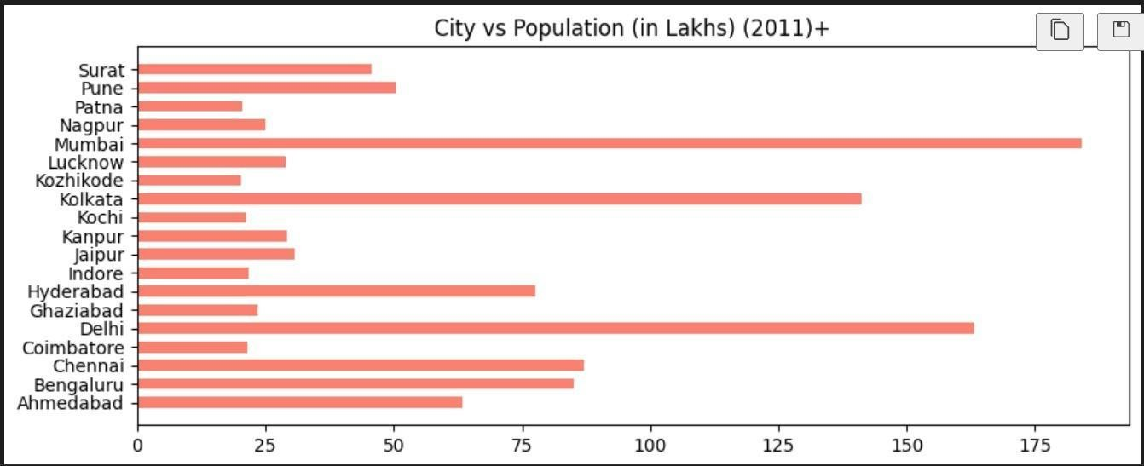

Fig 5.1. City vs Population graph
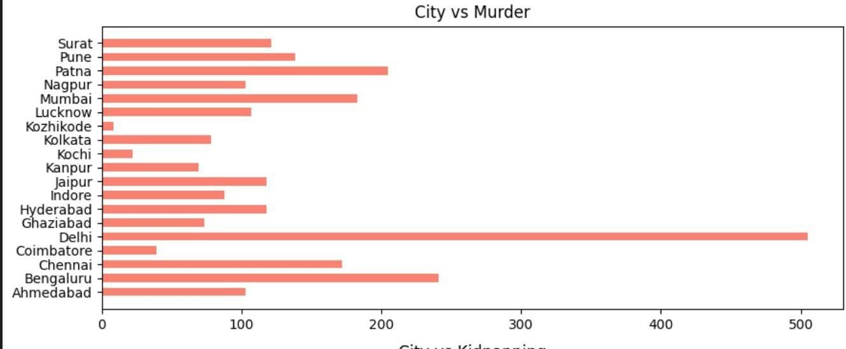

Fig 5.2. City vs Murder graph
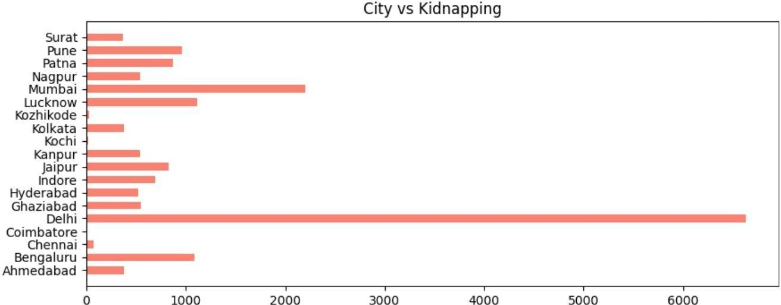

Fig 5.3. City vs Kidnapping graph

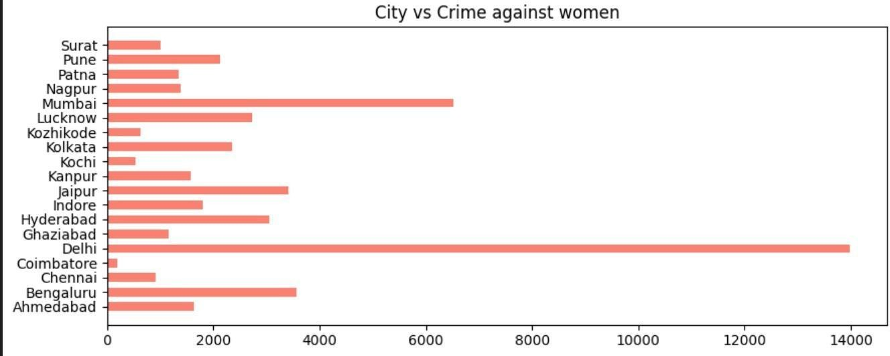

Fig 5.4. City vs Crime against women graph
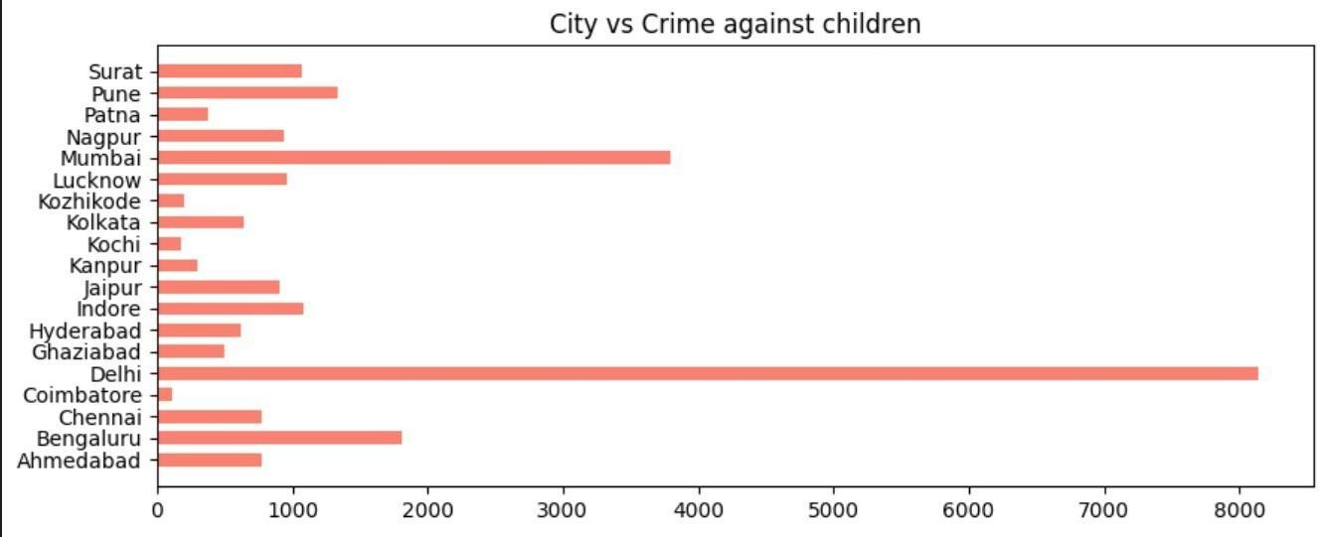

Fig 5.5. City vs Crime against children graph
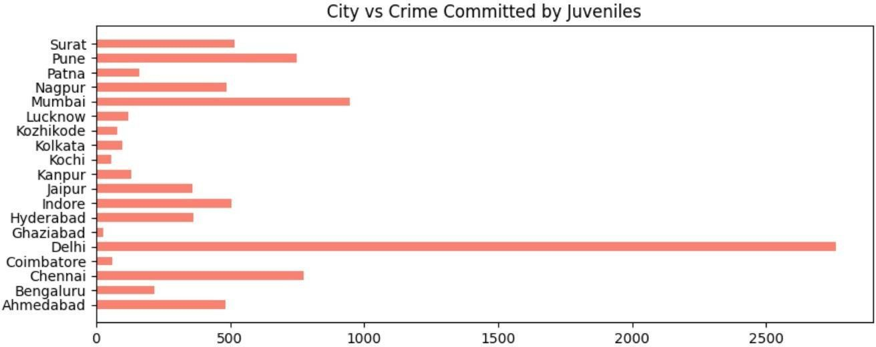

Fig 5.6. City vs Crime committed by Juveniles graph

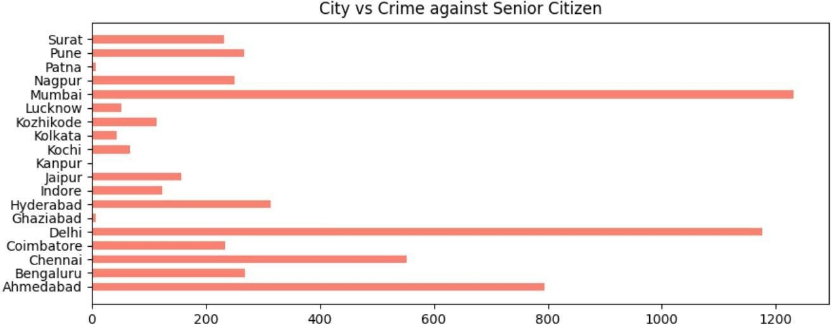

Fig 5.7. City vs Crime against Senior graph
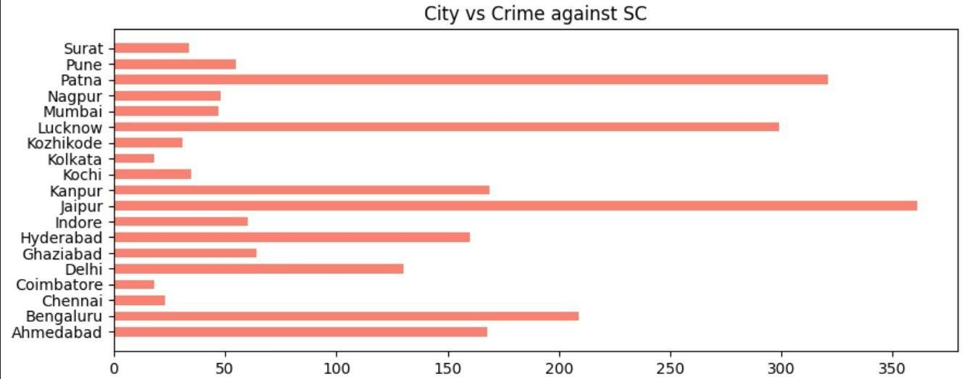

Fig 5.8. City vs Crime against SC graph
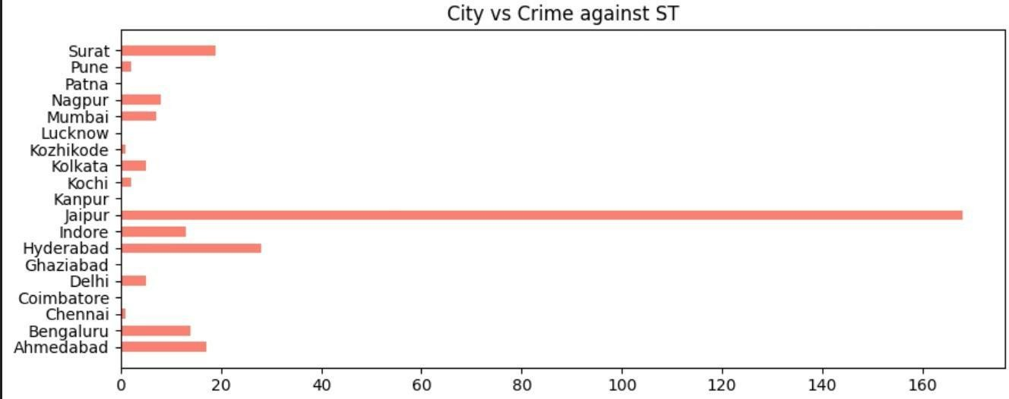

Fig 5.9. City vs Crime against ST graph

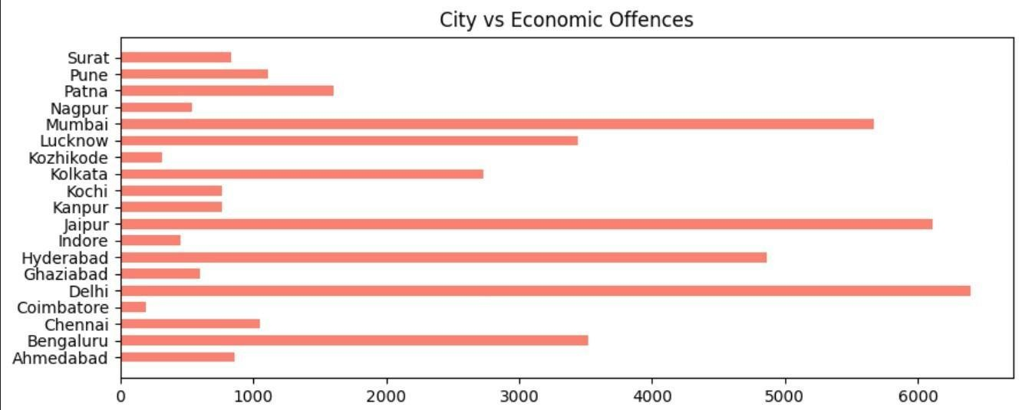

Fig 5.10. City vs Economic Offences graph
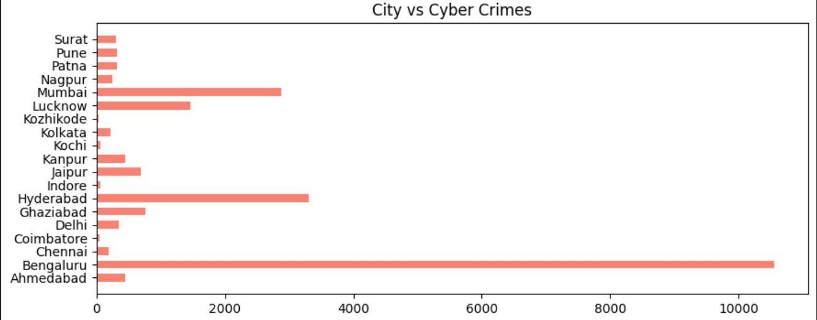

Fig 5.11. City vs Cyber Crimes graph

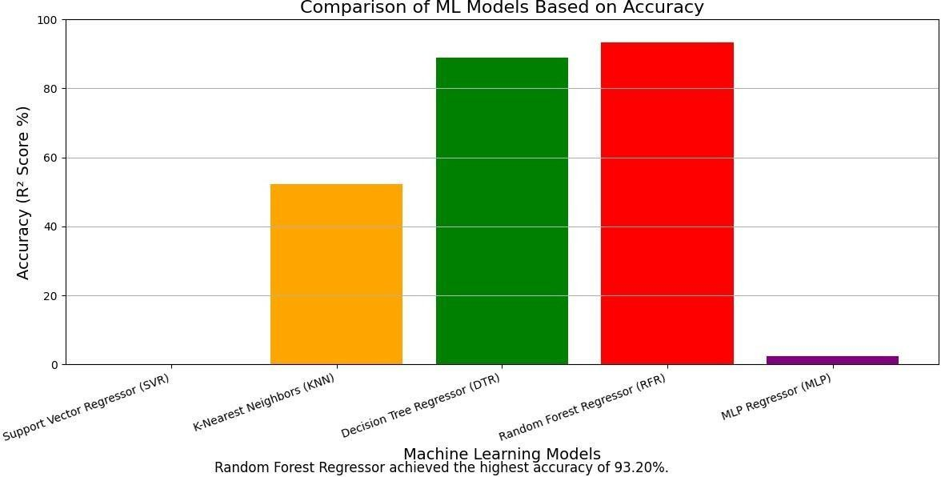

Fig 6.1 Comparison of Accuracy between different algorithms

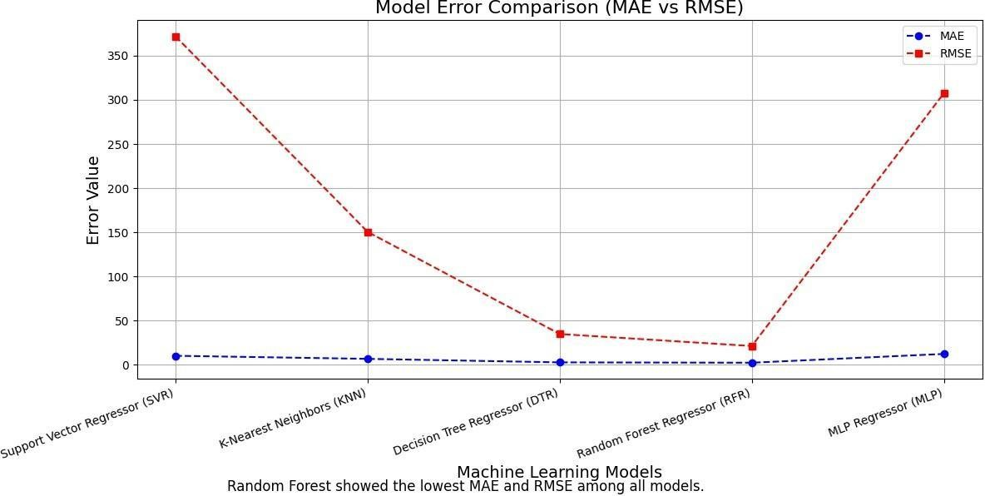

Fig 6.2 Comparison of Error between different algorithms
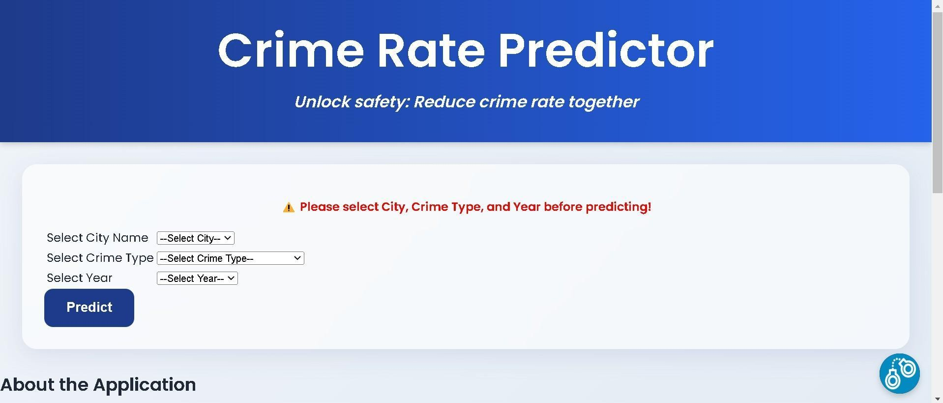

Fig 7. Main Page

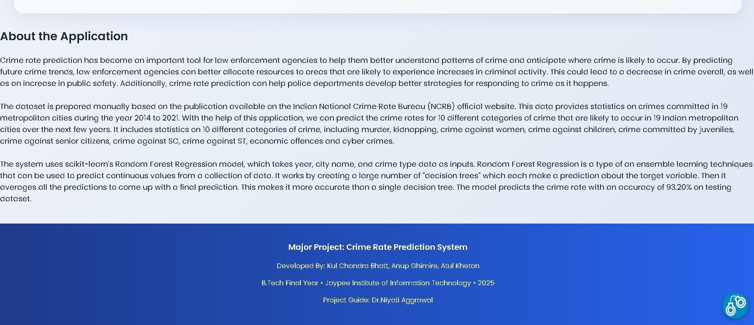

Fig 8. About

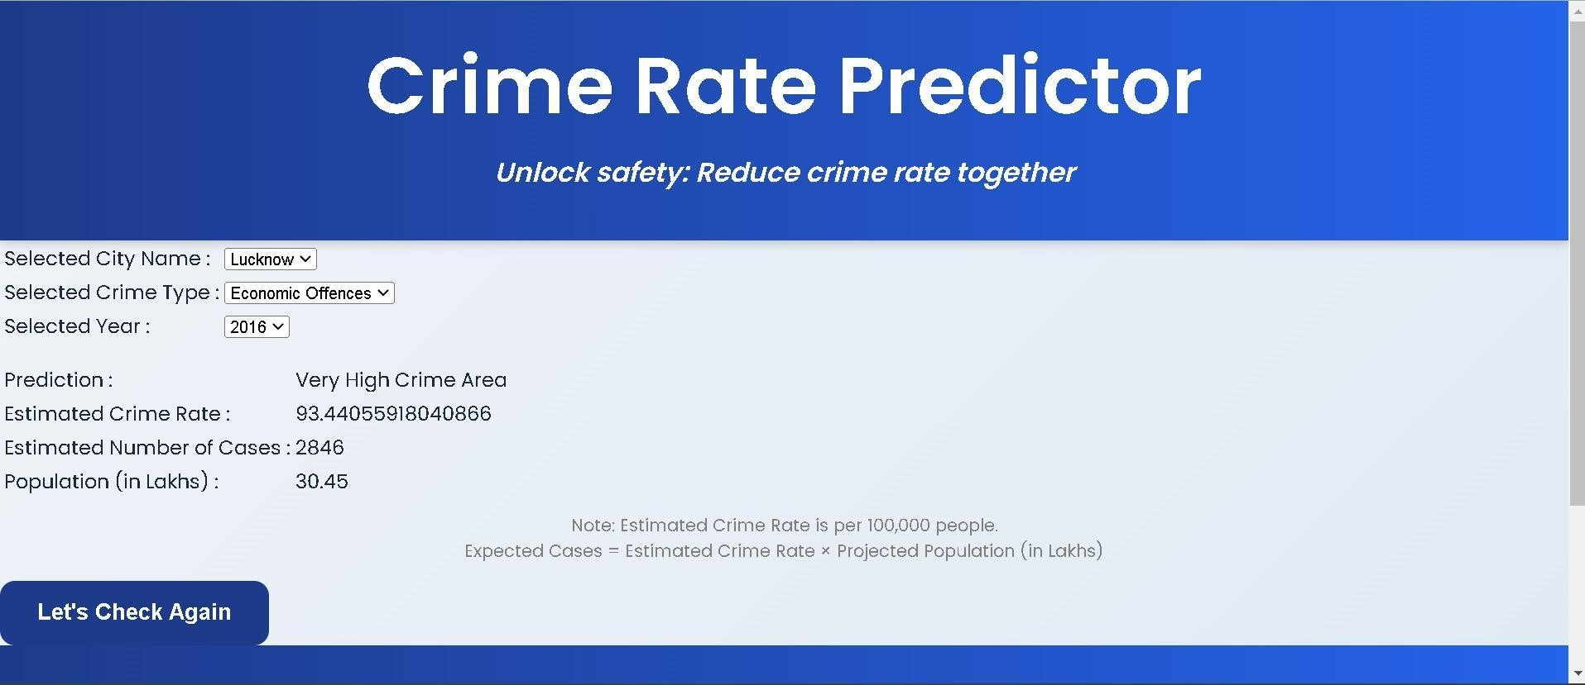

Fig 9. Working Model

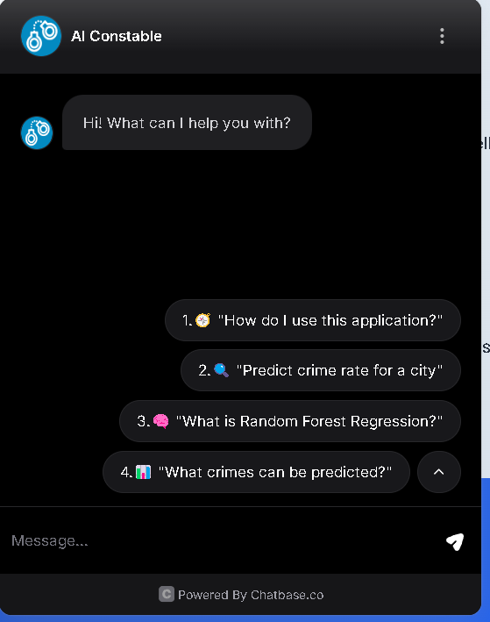

Fig 10. AI Constable(Chat Bot)

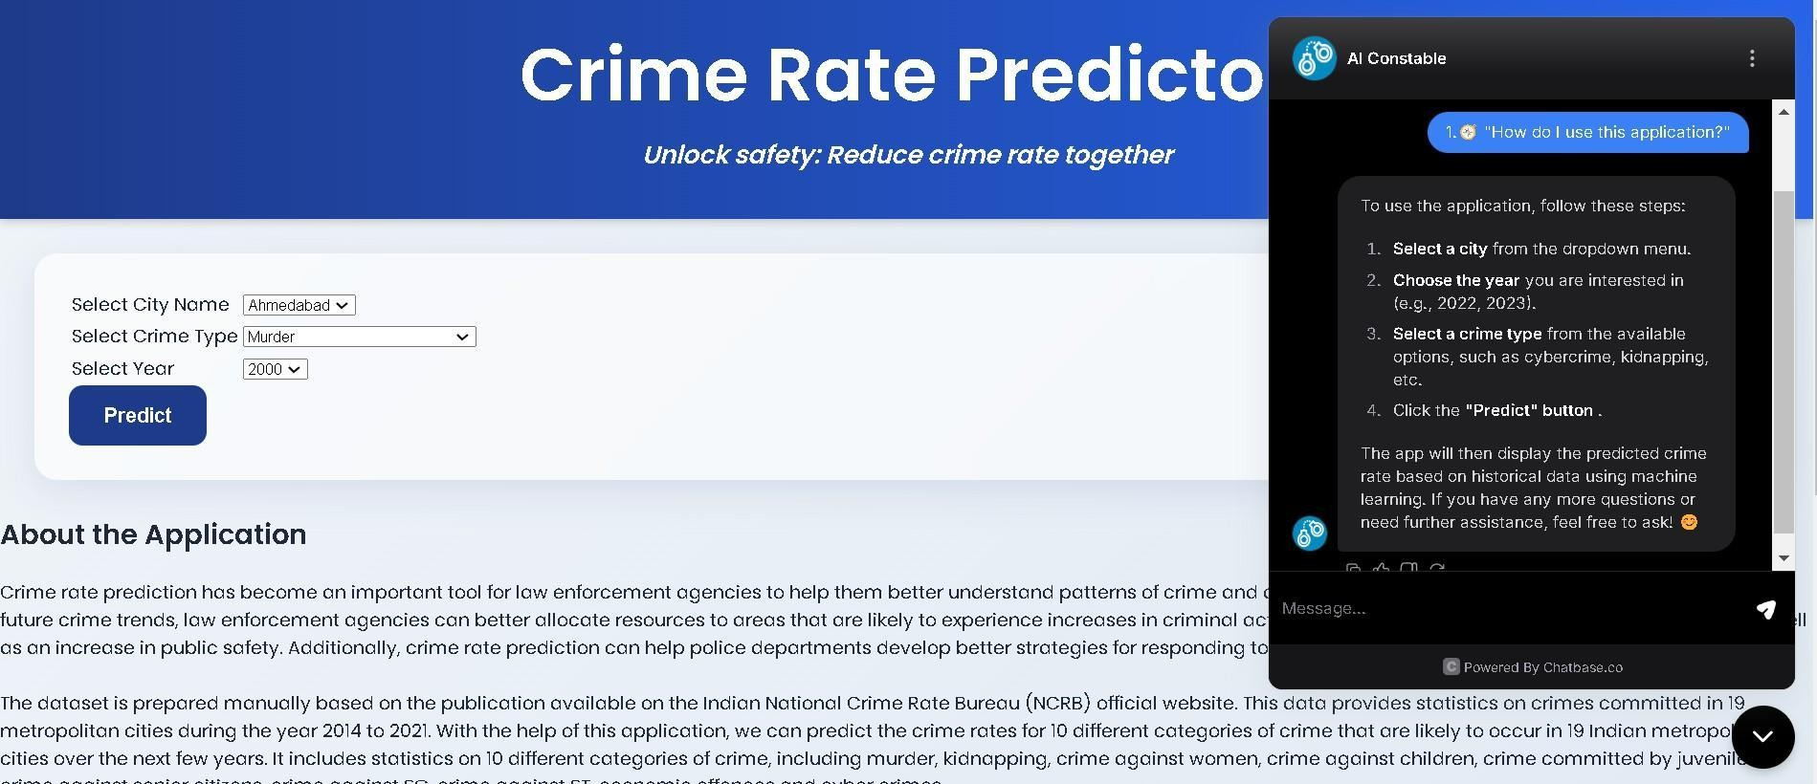

Fig 11. ChatBot FAQ

Multiple essential results emerged during the development stages of the Crime Rate Prediction System.

- The Random Forest Regressor yielded the best prediction accuracy during model tests (Random Forest, MLP Regressor, SVR, Decision Tree, KNN) when it achieved a R² score of 93.2%. Random Forest became the selected model for deployment.

- Population scaling logic represented a valuable addition that enhanced prediction confidence by adapting crime rate projections based on projected population changes between cities across years.

- Users could easily obtain information through the Chatbase-integrated chatbot about functionality of the application and its supported cities together with crime categories and emergency contact details. Users experienced better experiences because the system enabled quick reply time.

- Users interacted smoothly with the system through the basic interface designed for easy usage. The platform became user-friendly by having drop-down choices and easy-to-read output screens while clearly displaying emergency contacts for users to view.

- The system demonstrated reliable performance during testing because it generated successful outcomes in about 2 seconds while input validation systems stopped frequent mistakes.

  - Conclusion

The developed web application reached all the stated primary goals.

    - Predictions for 10 distinct crime categories emerge from the application through its analysis of historical National Crime Records Bureau data obtained from 19 metropolitan regions.
    - Users gain access to enter data which the system uses for predicting future crime risks.

    - The application assists users to raise their awareness level through both emergency contact features and guide functions provided by the chatbot.
    - The system developed reliability because it used ensemble machine learning approaches combined with user-friendly interfaces and basic chatbot functionalities.

The project shows how law enforcement institutions and community members gain useful data-driven information through artificial intelligence systems and data-based procedures leading to improved decision-making for public safety establishments.
  - Future Work

The following future improvements will bring additional features as well as expanded functionalities to the Crime Rate Prediction System:
Voice Assistant Integration:

Such a system allows users to communicate through voice commands for supplying city names and crime types and query requests.
Multilingual Support:

The program interface and the chatbot dialogue must be available in various Indian languages including Hindi as well as Bengali and Marathi to enhance user accessibility.
Real-Time Crime Data Integration:

The system must use real-time police database feeds to automatically update its predictions and send alerts.
Heatmaps and Geospatial Analysis:

Particular city heatmaps developed with Leaflet.js or Mapbox would generate visual data to indicate danger zones.
Advanced Chatbot Enhancement:

NLP techniques should be implemented to enhance the system because they will enable chatbot question handling functions that replicate human interaction.

Administrative Dashboard:

Users accessing the admin panel can easily deal with new city additions while modifying datasets and performing model returns through seamless processes that prevent significant source code changes.
Future improvements for the Crime Rate Prediction System will create an advanced comprehensive system brand that functions as an indispensable tool for crime prevention alongside community involvement efforts.

References

- M. Alkaff, N. F. Mustamin, and G. A. A. Firdaus, "Prediction of Crime Rate in Banjarmasin City Using RNN-GRU Model," International Journal of Intelligent Systems and Applications in Engineering, vol. 10, no. 3, pp. 01–09, 2022. Available: https://www.ijisae.org/index.php/IJISAE/article/view/2130
- W. Safat, S. Asghar, and S. A. Gillani, "Empirical Analysis for Crime Prediction and Forecasting Using Machine Learning and Deep Learning Techniques," IEEE Access, vol. 9,
pp. 1–1, 2021. Available: https://ieeexplore.ieee.org/document/9424589

- Gaurav Hajela, Dr. Meenu Chawla, and Dr. Akhtar Rasool, "A Clustering Based Hotspot Identification Approach For Crime Prediction," Procedia Computer Science, vol. 167, pp. 1462–1470, 2020.
- Masoomali Fatehkia, Dan O’Brien, and Ingmar Weber, "Correlated impulses: Using Facebook interests to improve predictions of crime rates in urban areas," Computational Social Science, 2019.
- Kanazawa S. and Still M. C., "Why Men Commit Crimes (and Why They Desist)," Sociological Theory, vol. 18, no. 3, pp. 434–447, 2000. DOI: https://doi.org/10.1111/0735-2751.00110
- Ms. Vrushali Pednekar, Ms. Trupti Mahale, Ms. Pratiksha Gadhave, and Prof. Arti Gore, "Crime Rate Prediction Using KNN," International Journal on Recent and Innovation Trends in Computing and Communication, vol. 6, no. 1, pp. 124–128, 2018. DOI: https://doi.org/10.17762/ijritcc.v6i1.1392
- C. Boukhatem, H. Y. Youssef, and A. B. Nassif, "Heart Disease Prediction Using Machine Learning," 2022 Advances in Science and Engineering Technology International Conferences (ASET), Dubai, United Arab Emirates, 2022, pp. 1–6, doi: 10.1109/ASET53988.2022.9734880.
- L. Wu et al., "A Survey on Large Language Models for Recommendation," arXiv preprint
arXiv:2305.19860, May 2023.

- Z. Yue, S. Rabhi, G. de Souza Pereira Moreira, D. Wang, and E. Oldridge, "LlamaRec: Two-Stage Recommendation using Large Language Models for Ranking," arXiv preprint arXiv:2311.02089, Oct. 2023.
- N. Kosarkar et al., "Disease Prediction using Machine Learning," 2022 10th International Conference on Emerging Trends in Engineering and Technology - Signal and Information Processing (ICETET-SIP-22), Nagpur, India, 2022, pp. 1–4, doi: 10.1109/ICETET-SIP-2254415.2022.9791739.
- A. Vaswani et al., "Attention is all you need," in Advances in Neural Information Processing Systems 30 (NeurIPS 2017), Long Beach, CA, USA, 2017, pp. 5998–6008.
- I. Sutskever, O. Vinyals, and Q. V. Le, "Sequence to sequence learning with neural networks," in Advances in Neural Information Processing Systems 27 (NeurIPS 2014), Montreal, Canada: Curran Associates, Inc., 2014, pp. 3104–3112.
- D. Bahdanau, K. Cho, and Y. Bengio, "Neural machine translation by jointly learning to align and translate," presented at the 3rd International Conference on Learning Representations (ICLR), San Diego, CA, USA, May 7–9, 2015.
- J. Howard and S. Ruder, "Universal language model fine-tuning for text classification,"
arXiv preprint arXiv:1801.06146, May 2018.

- K. Bennani-Smires et al., "Simple unsupervised keyphrase extraction using sentence embeddings," in Proc. 22nd Conf. Computational Natural Language Learning (CoNLL 2018), Brussels, Belgium, Oct. 2018, pp. 221–229.
- Wajiha Safat, Sohail Asghar, and Saira Andleeb Gillani, "Empirical Analysis for Crime Prediction and Forecasting Using Machine Learning and Deep Learning Techniques," IEEE Access, vol. 9, pp. 1–9, 2021.
- M. Shah, S. Degadwala, and D. Vyas, "Diet Recommendation System based on Different Machine Learners: A Review," 2022 Second International Conference on Artificial Intelligence and Smart Energy (ICAIS), Coimbatore, India, 2022, pp. 290–295, doi: 10.1109/ICAIS53314.2022.9742919.

- L. Athota, V. K. Shukla, N. Pandey, and A. Rana, "Chatbot for Healthcare System Using Artificial Intelligence," 2020 8th International Conference on Reliability, Infocom Technologies and Optimization (ICRITO), Noida, India, 2020, pp. 619–622, doi: 10.1109/ICRITO48877.2020.9197833.
- P. Hema, N. Sunny, R. Venkata Naganjani, and A. Darbha, "Disease Prediction using Symptoms based on Machine Learning Algorithms," in Proc. 2022 Int. Conf. Breakthrough in Heuristics and Reciprocation of Advanced Technologies (BHARAT), 2022, pp.

21103292_Crime Rate Prediction Using Machine Learning

ORIGINALITY REPORT
8

%
SIMILARITY INDEX
6%
INTERNET SOURCES
3%
PUBLICATIONS
4%
STUDENT PAPERS

PRIMARY SOURCES

www.slideshare.net
1
Internet Source

2 Qifen Dong, Ruihui Ye, Guojun Li. "Crime amount prediction based on 2D convolution
and long short‐term memory neural network", ETRI Journal, 2022
Publication

3 Submitted to Indian Institute of Technology Guwahati
Student Paper

de.slideshare.net
4
Internet Source

vdocuments.mx
5
Internet Source

github.com
6
Internet Source

7 Gaurav Hajela, Meenu Chawla, Akhtar Rasool. "A Clustering Based Hotspot Identification
Approach For Crime Prediction", Procedia Computer Science, 2020
2%
1%

1%

1%
1%
<1%
<1%

8

9

10

11

12

13

14

15

16

17
Publication

Submitted to KUMARAGURU COLLEGE OF TECHNOLOGY
Student Paper

www.coursehero.com
Internet Source

www.ijisae.org
Internet Source

"Proceedings of International Conference on Recent Innovations in Computing", Springer Science and Business Media LLC, 2024
Publication

ijrpr.com
Internet Source

Submitted to University of Westminster
Student Paper

Submitted to University of West London
Student Paper

bip.lasowicewielkie.pl
Internet Source

www.koreascience.kr
Internet Source

"ICT Systems and Sustainability", Springer Science and Business Media LLC, 2025
Publication

<1%

<1%
<1%
<1%

<1%
<1%
<1%
<1%
<1%
<1%

Exclude quotes On Exclude bibliography On
Exclude matches < 14 words

